Fixguru — Item Historical Pricing Demo — Issues (2026-07-17)

Overview
Demo/test session for the new Item Historical Pricing feature (Fixguru). Attendees: Gareth, Marcus (Fixguru), Yvonne, Jernnifer Transcript: Fireflies.

Issues Identified
- System instability / OpenAI outage — Backend/AI model down during demo, blamed on OpenAI-side outage. Caused error responses ("I apologize but I encounter an error").
- Slow response time — Order creation took 1–2 minutes per action during test (normally fast), attributed to system recovery + backend load.
- Historical price not returned for existing customer — Customer with confirmed March 2026 past order returned "no past customer price found." Backend record exists (confirmed for one customer case) but not surfaced — sync gap between backend and UI.
- Customer name match too strict — Lookup requires exact customer name match; no fuzzy/partial matching.
- No price-history preview on draft SO — Draft sales orders don't show price history / PDF preview by default; PDF only generates after submission. Workaround: user can explicitly request a draft PDF, but it's not the default flow.
- Inconsistent output for identical prompts — Same prompt run by different testers (and reproduced by Jared) returned different results. Suspected session/cache/connection sync issue, unresolved during call.
- PDF template mismatch — Current SO PDF layout differs from Fixguru's legacy AutoCount template; fix in progress.
- Draft SO number/ID issue — Sales order ID/numbering in draft state flagged as incorrect; tied to backend fix.
- Shared admin login for testing — All testers using one shared admin account; no individual credentials yet, limiting audit/tracking.
- Test setup confusion — Testers on different WhatsApp numbers within same test chat; unclear if this affects session/output isolation.
- Link access friction — Initial confusion on whether pricing shows in WhatsApp vs. a separate link-based UI; login credentials only shared mid-call.

Action Items
Gareth
- Coordinate with backend team to fix customer price history retrieval and sales order ID issues
- Share individual user account + password per tester (replacing shared admin login)
- Test chatbot stability internally before wider team testing
- Update group once system issues are resolved and testing can continue
Anthony / Marcus (Fixguru)
- Continue testing shared price-history link, report discrepancies in retrieval/output
- Test draft PDF generation and pricing consistency once backend is stable

Status
Meeting paused pending backend stabilization; to reconvene after fixes.
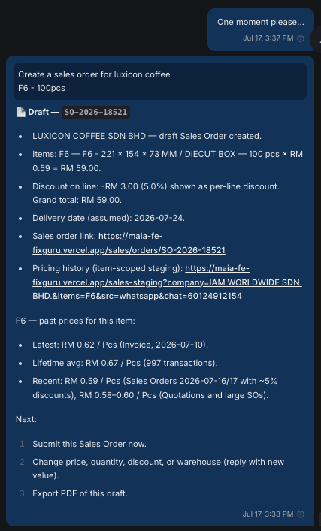
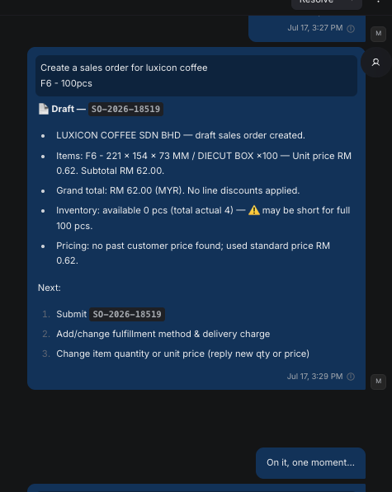
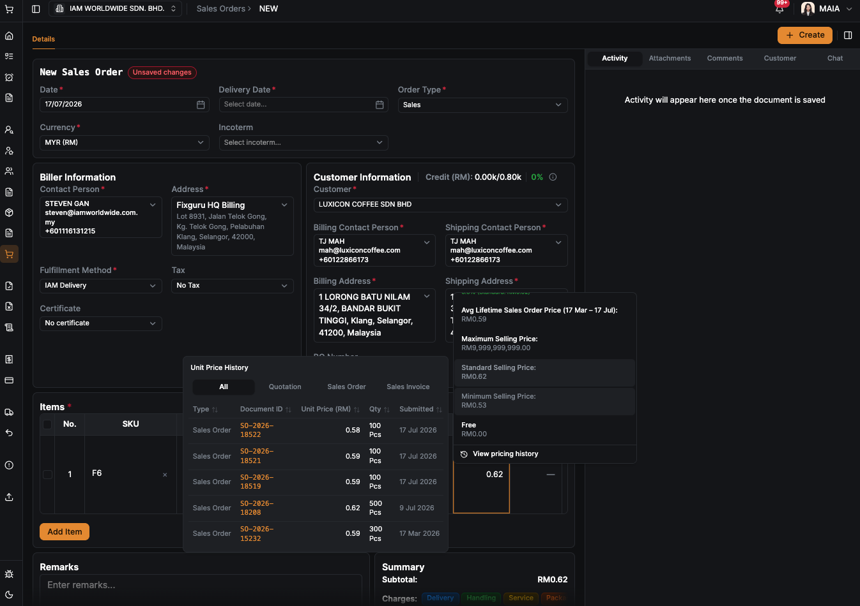
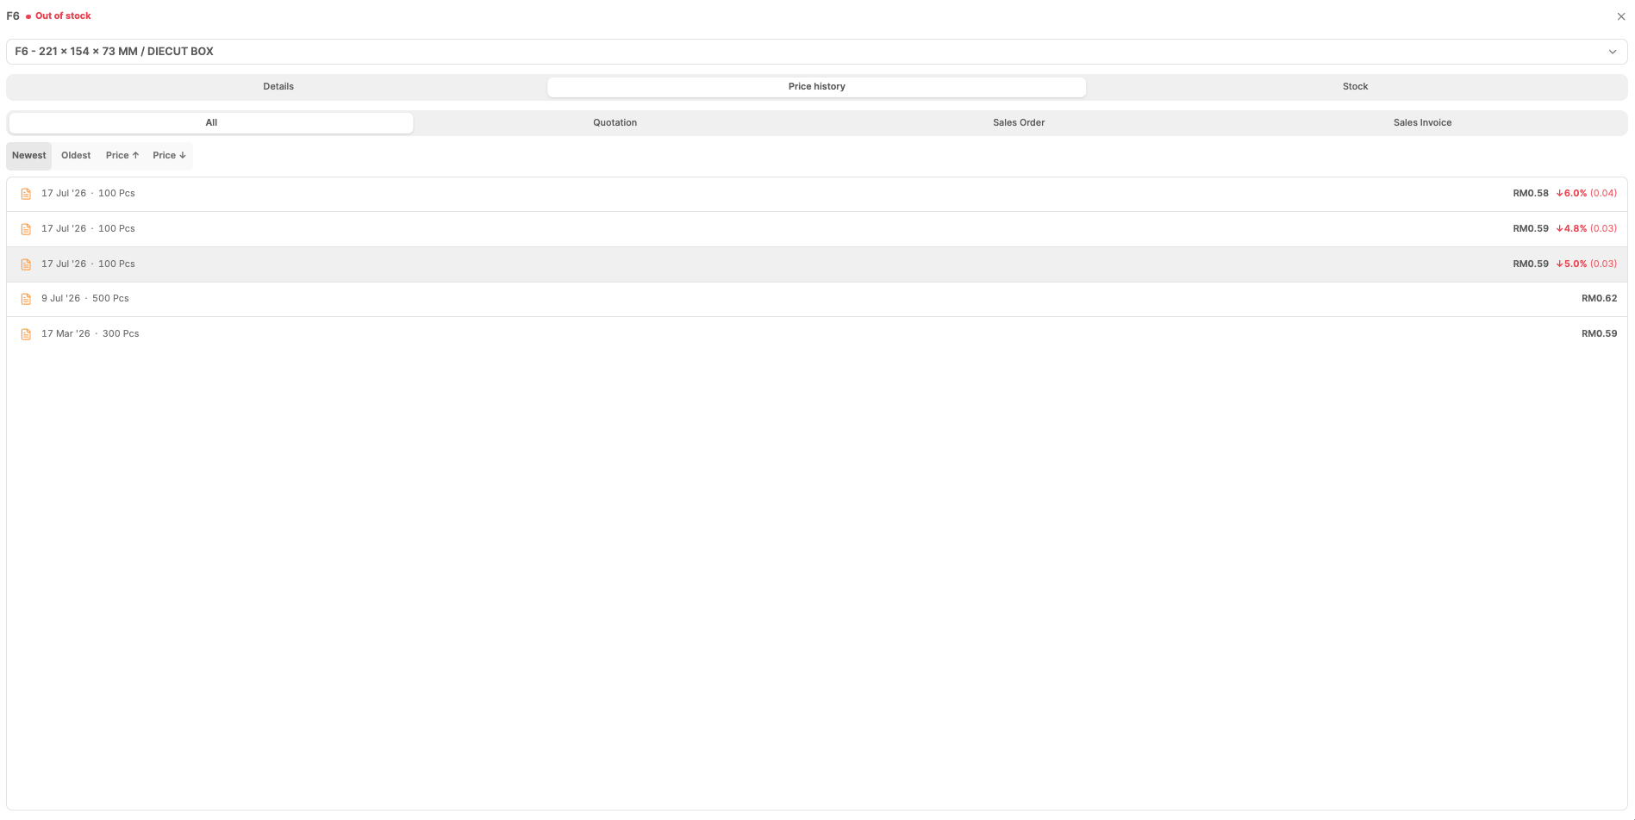
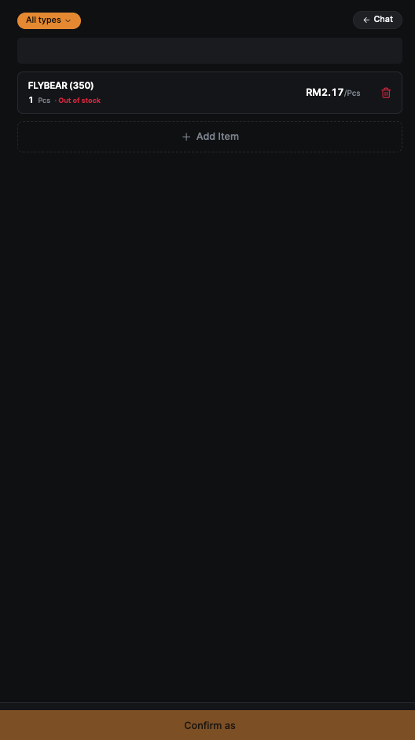
slow

